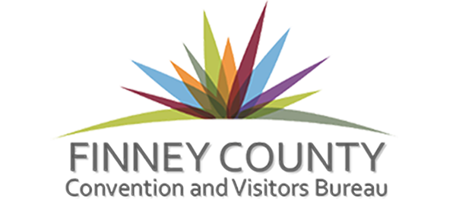

Post Event Analysis
As part of the grant you received from the Finney County Convention and Visitors Bureau please complete this form so that we may study the economic impact that was made from your event. If you have any questions, please call us at 276-0607 or email Melissa at msowers@finneycountycvb.com.

We have recently reformatted our forms so all information should be a fillable field. Please contact us if you have any questions or problems with it.

Event Information

Event Name: Click or tap here to enter text.

Event Date: Click or tap to enter a date.

Event Location: Click or tap here to enter text.

Event Attendance: Click or tap here to enter text.
*If multiple days please list totals for each day if possible

How was attendance number figured? Click or tap here to enter text.

First time Event: Yes ☐ No ☐

If no how many years has event been held? Click or tap here to enter text.

Number of Guests Lodging from Event: Click or tap here to enter text.

Number of rooms booked in Finney County as a result of this event: Click or tap here

How many nights? Click or tap here to enter text.

What hotels did the guest stay at? Click or tap here to enter text.

Was there admission charged to the event? Yes or No

How much per person? $ cost of admission
To figure economic impact, please use the following formulas:

Guest who stayed overnight = $160 – Please keep in mind that not each individual guest has their own room. Please use numbers of rooms and not total guests when figuring this number

$160 X # of overnight rooms X # of days. = $

Out-of-town day trip visitors = $60 –people who traveled from outside of the county

$60 X number of guests X # of days = $

Locals who attended the event =$15 –people who live within Finney County

$15 X number of guests X # of days = $

Approximate economic impact the event had? $_______

Any money spent locally counts towards your Economic Impact. This includes facility rental, banquet food costs, supplies/gifts purchased in Finney County, advertising with local agencies, etc. If you have additional items that figure into the economic impact, please list them here:
Click or tap here to enter text.
How was event advertised and promoted? How were Garden City businesses promoted to participants? (Be specific)
Click or tap here to enter text.

Please attach:
- Copies of actual expenses vs budgeted expenses – FINAL BUDGET
- Examples of all printed materials, screen captures of websites, social media outlets, and samples of promotional materials used to market your event/project
- Examples of how the FCCVB logo was used
- Where and when the FCCVB was mentioned in radio and television advertising
- Promotional items that were branded with the FCCVB logo
- Copies of receipts for all services received and/or items purchased with FCCVB grant funds

Please attach additional sheets if needed to answer any of the above questions and to provide additional information about the event

Authorized Signature Date

Print name here Title/Responsibility

The signee is confirming that what is reported is accurate and all requested information has been included.
Return this form, and any supporting documentation that you feel would be helpful to evaluate the event and its economic impact on the community.

