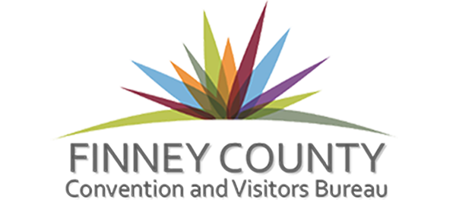

FCCVB Marketing Co-op Application
To apply for a marketing co-op from the Finney County Convention and Visitors Bureau (FCCVB), complete this form in its entirety and submit. Please keep in mind that in order to qualify for a FCCVB co-op, you must demonstrate that an event or project will attract overnight visitors or have significant Economic Impact to Finney County, so please provide us with as much information as you can.

There are 2 grant periods during the year for applications to be accepted
- For events happening between January and June the application is due in October and partnership announcements are made in November
- For events happening between July and December the application is due in April and partnership announcements are made in May

All applications are reviewed by the Partnership Committee and their recommendations on amounts awarded are presented to the board for final approval

Please remember that all events will be listed on the CVB’s event calendar so please make sure to include as much information as possible and please keep us updated of any changes on times, locations, etc.

If you have any questions please reach out to the Melissa Sowers at the CVB office for assistance at 620-276-0607.

All completed applications can be submitted in person at the CVB office or emailed to msowers@finneycountycvb.com

Please fill the application out in its entirety and make sure to attached the requested documentation such as proposed budget (we now have a template that is free to download and use for all events).

Make sure your numbers are realistic in budget, number of room nights, visitors, etc. If you are showing a major increase in attendance due to something new or an anniversary please be sure to include the information to support your increase.

Be sure to remember that the max amount to request is $3,000 (this has changed from years past) or no more than 40% of your overall budget.
We have recently reformatted our forms so all information should be a fillable field. Please contact us if you have any questions or problems with it.

Event Manager/Executive Board or Organizing Committee

Event Planner/Manager Name and Contact Information
Contact Person | Click or tap here to enter text.
Organization | Click or tap here to enter text.
Street Address | Click or tap here to enter text.
City/State/Zip | Click or tap here to enter text.
Telephone | Click or tap here to enter text.
Email | Click or tap here to enter text.

Project/Event Information/Amount Requested
Name of event/project | Click or tap here to enter text.
Date(s) of event/project | Click or tap here to enter text.
Times of event/project | Click or tap here to enter text.
Location | Click or tap here to enter text.
Ticket price | Click or tap here to enter text.
Total event budget | Click or tap here to enter text.
Marketing Co-op Requested | Max of $3,000 or 40% of budget
Marketing Co-op check made out to | Click or tap here to enter text.
Contact person for questions from public | Click or tap here to enter text.
Contact number for questions from public | Click or tap here to enter text.

Event Description
Describe the event and its various elements in more detail. Give an overview of the intended event content or program. You may copy and paste text into the box below; it will expand automatically.
Click or tap here to enter text. The box will expand as you type or copy & paste.

Mission Statement/Objectives
Mission Statement
The mission statement should indicate what the event is trying to achieve and who would be attracted to come. The mission statement should be about two sentences long and answer the following questions:
- Who are your visitors and what are their entertainment needs?
- What are the core activities of our committee or board, and why are these activities important?
- How can we use the event to promote our area?
State the Mission Statement of your event in the box below. You may copy and paste text into the box; it will expand automatically.
Click or tap here to enter text. The box will expand as you type or copy & paste.

Objectives
Just a few words are all that is required for each objective. After the event is over, you will then be able to review the outcome of the event against your objectives. Some examples are:
- Attract a minimum of 1500 visitors; 500 of those will travel further than 90 miles to come.
- Generate at least 100 room rentals in Garden City.
- Have an economic impact of no less than $25,000.
State the Objectives of your event in the box below. You may copy and paste text into the box; it will expand automatically.
Click or tap here to enter text. The box will expand as you type or copy & paste..

Master Event Timeline
An effective event planning timeline serves as a blueprint for a successful event. A master event timeline is an outline of all of the tasks that must be completed in the order they need to be addressed to ensure that your event runs smoothly without any major problems.
Create your master event timeline on a spreadsheet. Submit this timeline with your marketing co-op application.
Don’t forget to add Post Event that is due to the CVB no later than 45 days after completion of event.
If an extension is needed you must contact the FCCVB for approval.

Financial Planning –Outside Funding/Event Budget

Outside Funding
Please list below all grants, sponsorships, and in-kind funding you have secured for this event. If you need additional space, you may add lines or submit this separately on an Excel spreadsheet.

Funding Source Name | In-kind funding or dollar amount? | Dollar amount or value of  in-kind transaction
enter text. | enter text. | enter text.
enter text. | enter text. | enter text.
enter text. | enter text. | enter text.
enter text. | enter text. | enter text.

Proposed Budget
Use a spreadsheet to draw up a detailed budget of projected income and expenditures for the project. Submit this budget with your grant request.
You will be asked to submit a final budget with your Post Event.
An excel template can be found on our website for you to use if needed

Event Details and Specifics

Is this a new event? ☐Yes ☐No

Will the event occur on a weekend? ☐Yes ☐No

Will the event last more than one day? ☐Yes ☐No

What is unique about the event?
Click or tap here to enter text.

What are businesses will benefit from the event?
Click or tap here to enter text.

- What will be the overall benefit to tourism in Finney County?
Click or tap here to enter text.

- Will you be working with other events occurring at that time to share advertising/marketing for your events? If so, list who you will be working with and provide details about the marketing partnership.
Click or tap here to enter text.

Estimated Number of Visitors
Please provide the number and type of visitors you expect to attend your event.
Locals (people who live in Finney County) | Number of Locals
Day trippers (people who live outside the county, but will probably not spend the night) | Number of Day Trippers
Overnight visitors (people who will spend the night in a local hotel or inn; do not include people whose rooms will be comped [free]) | Overnight Visitors
How are you determining these numbers? | Click or tap here to enter text.
How do you plan on tracking these numbers at event? | Click or tap here to enter text.

Existing Event
If your project or event is new, please skip this section and answer the questions in the New Project or Event section.
- How many times or how long has this event been held?
Click or tap here to enter text.

- Is the event growing? Explain.
Click or tap here to enter text.

- Does your project or event attract overnight visitors to Finney County? Explain.
Click or tap here to enter text.

- What is the history of overnight visitors for the event?
Click or tap here to enter text.

- Is the history of overnight visitors showing signs of growth or consistency? Explain.
Click or tap here to enter text.

- How have you marketed this event in the past? Be sure to include all publicity and media exposure in addition to advertising.
Click or tap here to enter text.

- Have you utilized social media (Facebook, Twitter, etc.) to publicize your project/event? If you have not used social media in the past, will you use it to publicize future events? How?
Click or tap here to enter text.

- If you are using social media please list your page names, handles, #s etc and website(s)
Facebook | Click or tap here to enter text.
Twitter | Click or tap here to enter text.
Instagram | Click or tap here to enter text.
#’s (Hashtags) | Click or tap here to enter text.
Website | Click or tap here to enter text.

- Are you planning any new or different activates or other ideas to increase overnight visitors?
Click or tap here to enter text.

New Project or Event
If your event is new, please answer the following questions:
- How are you estimating the number of overnight visitors, day trip visitors, and locals who will attend the event?
Click or tap here to enter text.

- How did you determine the elements within your budget, i.e., income and expenditures?
Click or tap here to enter text.

- Schedule time to meet with CVB staff to go over application and event. Conversation with CVB staff must take place before application will be accepted for new events.
FCCVB Marketing Co-op Request Checklist
Before you submit your co-op request, please go through the checklist below to be sure you have included all the required information.
☐ Complete the co-op request form in its entirety
☐ List of board/committee members
☐ Master Event Timeline
☐ Event Budget
☐ Signed the Acknowledgement of Marketing Co-op Program Guidelines and Policies
☐ Filled out the Event Calendar Form
☐ COVID-19 SAFTEY PROTOCOLS

Acknowledgement of Program Requirements

New Event Suggestions – Creating an Event Plan
We want your event to be a success! Before your application can be accepted you need to set up a meeting with CVB staff to review it and the event.

New & Existing Event Requirements
You must use the current Convention and Visitors Bureau logo on marketing and media advertising. Please provide copies of any/all posters, brochures, social media ads, scripts of radio and/or T.V. ads, etc.
*The Finney County Convention and Visitors Bureau has an updated logo. We can provide it to you in many different formats. Please contact us to make sure you have the current one.
**Current logos can be downloaded from the CVB website on the Marketing Co-op page**

Post-event Requirements
You must submit a post-event report (complete with receipts of expenditure and economic-impact data) to the FCCVB no later than 45 days after your event is over. Failure to meet this deadline will result in the loss of ability of event/business/group to qualify for future applications.

Submitting the Post-Event Report
- The FCCVB will provide you with a post-event report for you to use to detail your accounting and compile your economic-impact data.
- Complete the report in its entirety and provide the following:
- Copies of all other receipts and invoices for the event (you are required to provide all your receipts and invoices for validation of the budget you submitted as part of your co-op request).
- A completed Final budget
- Copies of all marketing examples

An important note about the Post-Event Report
Should you miss the 45-day deadline and forfeit your remaining co-op funds, it is still important to submit a post-event report. Failure to submit this report result in the following:
- The event becomes ineligible to receive co-op for the next calendar year.
- The person responsible for submitting the post-event report (usually the person listed as the contact on the co-op application) becomes ineligible to submit a co-op application on behalf of any organization or event, until/unless reinstated by a vote of the FCCVB board.

Acknowledgement of Marketing Co-op Program Guidelines and Policies
I have read and understand the FCCVB Marketing Co-op Program Guidelines and Policies. I understand that knowingly providing false information in this co-op application is a violation of Kansas law. I further understand that if I do not complete and submit a post-event report to FCCVB within 45 days after the completion of the event, it becomes ineligible for a co-op for the next calendar year and I will not be able to apply for any other FCCVB marketing co-op’s until I submit the required report.

Click or tap here to enter text. Enter date
Signature and Title of Grant Applicant |  | Date of Application

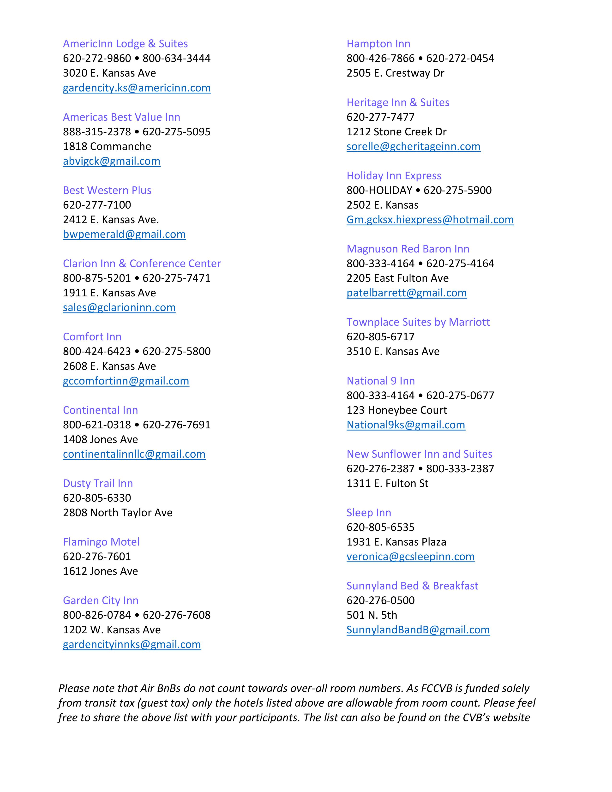
Finney County Hotels

Event Calendar Form
The CVB will add events going on in the Finney County area to their event calendar. Please fill out the information below. Remember that the more information the better chance people will attend the event, and all boxes will expand so please feel free to include as much info as you want.

Name of event/project | Click or tap here to enter text.
Date(s) of event/project | Click or tap here to enter text.
Times of event/project | Click or tap here to enter text.
Location | Click or tap here to enter text.
Ticket prices | Click or tap here to enter text.
Website for more information | Click or tap here to enter text.
Facebook Site name | Click or tap here to enter text.
Other website info | Click or tap here to enter text.
Contact person for questions from public | Click or tap here to enter text.
Contact number for questions from public | Click or tap here to enter text.
Please provide a description for your event that will be used in the event description on the calendar. | Click or tap here to enter text.
Please include any additional info | Click or tap here to enter text.

